## How to start the mysql server





Run this to start the mysql server In local machine

### Another way to start server

Goto Windows+r 🡪 search for services🡪

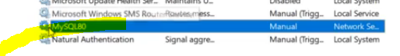

Right click and click start

To run the queries 🡪 launch mysql Workbench

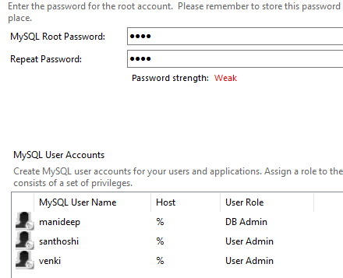

# Install mysql

<https://www.youtube.com/watch?v=GwHpIl0vqY4&ab_channel=AmitThinks>

install mysql using above link

After installing mysql , to the environment system variable “**Path**” add the below path

C:\Program Files\MySQL\MySQL Server 8.0\bin

After setting the environment variable , then in cmd type below command to check the installation status

mysql –version

# to start mysql server

login:- u can type all these commands in cmd prompt anywhere , because we have already set the properties to env variables

type “mysql –u root –p”

type “**show databases**” to see db list

### To create mysql database

to create database type “create database mani;”

### Keyboard shortcuts in mysql

To execute the selected query use shortcut- **ctrl+shift+enter**

Creating users in mysql

**create user 'manideep'@'localhost'**

**identified BY 'MANIDEEP'**

u can login and check using

**mysql –u manideep –p**

### Granting permissions

Unless the permissions are given to that databases, the new user can’t see that database

Grant create,alter,drop,delete,select

on mani.*

to 'manideep'@'localhost'

// if that user wants to run all select, insert queries then issue all those keywords

grant select,insert,update,delete

#here mani.* means all tables in mani database

on mani.*

#here we should tell to which user we should grant

to 'manideep'@'localhost'